* **Name of the Activity**: Lecture Series on the eve of 75th year of Bangiya Bigyan Parishad and Gyan o Bigyan Patrika
* **Date of the Activity:** 19.01.2023
* **Speakers:** 
  + Prof. Goutam Ganguly, Dept. of Physics, University of Calcutta
  + Prof. Rajarshi Ghosh, Dept. of Chemistry, University of Burdwan
* **Number of Participants:** 64
* **Organizing Department:** Seminar Sub-Committee, Chakdaha College
* **Brochure:**

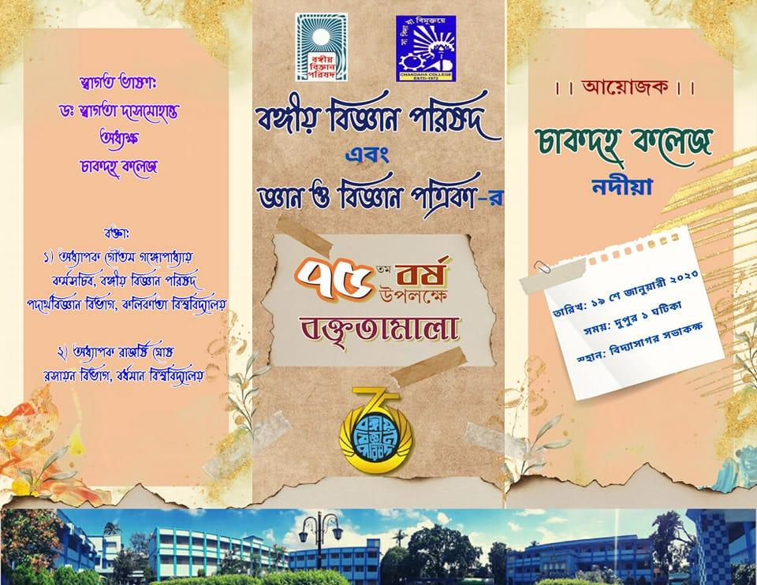

* **Link of the Acctivity:** <https://fb.watch/oRzTsN3t7h/>

<https://fb.watch/oRzVH2ww-g/>

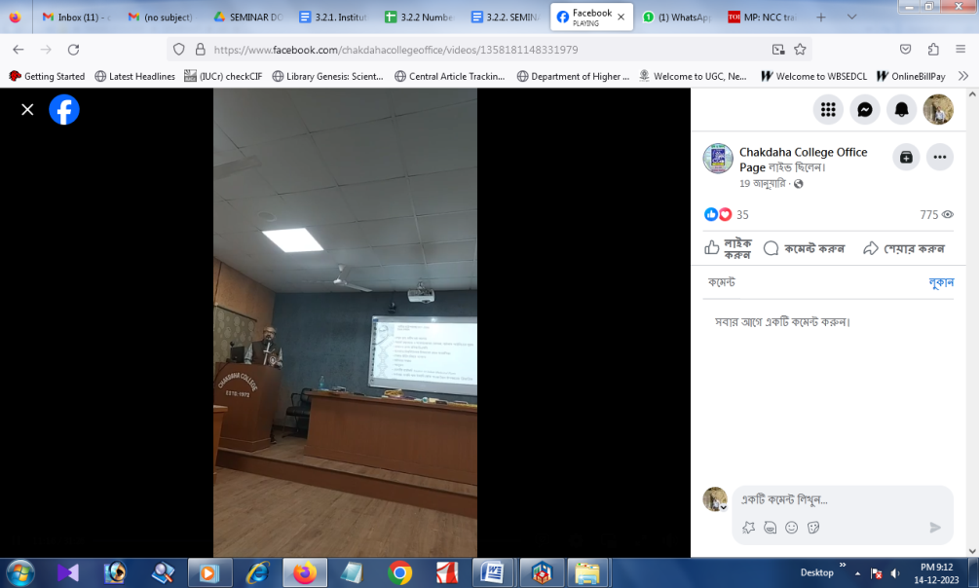

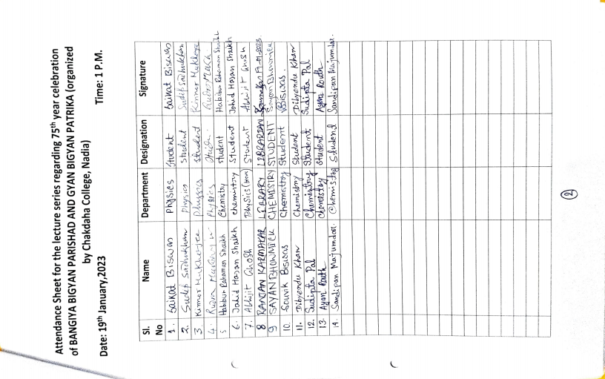Attendance:

